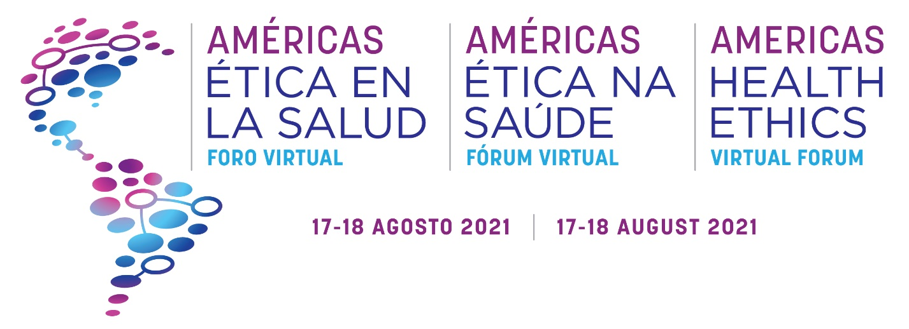

On 17-18 August 2021, nearly two dozen diverse organizations joined together to convene the Americas Health Ethics Virtual Forum. This hybrid event, hosted live from Brasília and virtually across the region, included nearly 1,000 participants and more than 50 speakers across 16 sessions totaling nine program hours, making it the largest and most diverse event ever held in the region focused on health ethics.

The speakers included 18 national and international governmental organizations, including the Pan American Health Organization (PAHO), the Inter-American Development Bank (IDB), the International Finance Corporation (IFC) of the World Bank Group, the Brazilian and Chilean Ministries of Health, the Brazilian Comptroller General of the Union and Federal Prosecution Service, the Chilean Ministry of Foreign Affairs, U.S. Departments of Commerce and State, the Brazilian Ministry of Economy, Fundação Getulio Vargas (FGV), the International Anti-Corruption Academy (IACA), the Brazilian Chamber of Deputies, and health regulatory authorities from Brazil (ANVISA), Colombia (INVIMA), Mexico (COFEPRIS), and the United States (FDA).

The Forum showcased advances made in ethics and business integrity, transparency, and good governance since the 8th Summit of the Americas hosted by Peru in 2018. The Forum also catalyzed significant progress in preparation for the 9th Summit of the Americas to be hosted by the United States in 2022. Key highlights at the Forum included:

- Launch of the Brazilian Consensus Framework for Ethical Collaboration in Health Sectors with endorsement from the Brazilian Minister of Health;

- Launch of a Memorandum of Understanding to foster new education collaborations that prevent corruption between Fundação Getulio Vargas (FGV) and the International Anti-Corruption Academy (IACA);

- Reaffirmation by the Inter-American Development Bank and Americas Business Dialogue of commitments to support collaborations that prevent corruption and foster ethics and business integrity;

- Reaffirmation by the U.S. Department of Commerce, Brazilian Ministry of Economy, and Chilean Ministry of Foreign Affairs on the connection between high-standard ethical business conduct and good regulatory practices with sustainable economic growth and trade;

- Reaffirmation by the President of Brazil’s Parliamentary Front Ethics Against Corruption (FECC) on the Chamber of Deputies commitment to prevent corruption in healthcare through elevating ethics and compliance;

- Presentation of Brazil’s national anti-corruption strategy by the Comptroller General of the Union;

- Presentation by the Advanced Medical Technology Association (AdvaMed) on the Global Distributors Compliance Toolkit, a free resource made available as open source for the entire region in Spanish, Portuguese, and English to help medical technology distributors and manufacturers implement high-standard ethics compliance programs as well as perspectives from leading medical technology industry groups in Argentina, Brazil, and Mexico;

- Presentation by the Basel Institute on Governance regarding collective action initiative best practices and an announcement of future mentorship support for Consensus Frameworks across the region;

- Presentation by the International Finance Corporation on the newly launched Ethical Principles in Healthcare (EPiHC) initiative and an open invitation for private healthcare providers, payors, and investors to join;

- Presentation by thought leaders from the International Federation of Pharmaceutical Manufacturers and Associations (IFPMA) and Illumina on emerging ethical dilemmas in patient data and health technologies, with actionable recommendations for the Americas focused on genomic data and artificial intelligence;

- Panel sessions with numerous, actionable recommendations focused on: (a) fostering integrity in industry-regulator interactions, (b) driving a level playing field through public procurement, (c) elevating patient recommendations to drive ethics in health data, (d) advancing healthcare professionals perspectives in ethical dilemmas amidst the COVID-19 pandemic; and

- Update by the U.S. National Summit Coordinator at the U.S. Department of State on preparations for the 2022 Summit of the Americas, including the likely importance of regional coordination in health amidst the pandemic.

Session Recordings (17 August 2021):

Americas Health Ethics Virtual Forum Opening Session, 17 August 2021 - YouTube

Launch of the Brazilian Consensus Framework for Ethical Collaboration, 17 August 2021 - YouTube

Integrity in Regulator-Industry Interactions: Learnings from the Pandemic, 17 August 2021 - YouTube

Elevating Integrity in Health Procurement: Learnings from the Pandemic, 17 August 2021 - YouTube

Signing Ceremony: Fundação Getulio Vargas and the IACA, 17 August 2021 - YouTube

Brazilian Congress Remarks, 17 August 2021 - YouTube

Unity for Integrity: Driving Regional Economic Growth and Trade through Ethics, 17 August 2021 - YouTube

Session Recordings (18 August 2021):

IDB Perspectives: Fostering Ethics and Integrity in Health for Regional Prosperity, 18 August 2021 - YouTube

Strengthening Collective Action for Integrity in Health: Consensus Frameworks, 18 August 2021 - YouTube

Emerging Ethical Dilemmas in Patient Data and Health Technologies, 18 August 2021 - YouTube

Patient Perspectives in Health Data Sharing and Privacy across the Americas, 18 August 2021 - YouTube

Special Remarks: Minister Wagner de Campos Rosário, 18 August 2021 - YouTube

The Role of Health Providers, Payors, and Investors in Driving Ethics and Integrity, 18 August 2021 - YouTube

Healthcare Professional Voices in Advocating Ethical Conduct, 18 August 2021 - YouTube

Innovative Solutions to Strengthening Ethical Third-Party Intermediary Relationships, 18 August 2021 - YouTube

Driving Regional Growth & Looking Ahead to the 9th Summit of the Americas, 18 August 2021 - YouTube

About the Summit of the Americas:

In 2022, the United States will host the 9th Summit of the Americas, which is administered by the Organization of American States. The Summit is held roughly every three years. Peru convened the 8th Summit of the Americas in 2018, where ethics, transparency, and good governance were key priorities. The Lima Commitment “Democratic Governance Against Corruption” was issued at the 8th Summit.

The Americas Business Dialogue, housed within the Inter-American Development Bank, simultaneously launched during the 8th Summit the ABD Action for Growth Policy Recommendations, including strengthening transparency and integrity, and the Inter-American Coalition for Business Ethics in the MedTech Sector.

Forum Partners: U.S. Department of Commerce, Inter-American Development Bank, Americas Business Dialogue, Health Ethics Institute of Brazil, Inter-American Coalition for Business Ethics in the Medical Technology Sector, Inter-American Coalition for Regulatory Convergence for the Medical Technology Sector, the IFPMA, AdvaMed, ABIIS, EPiHC, the Basel Institute on Governance, IACA, FGVethics, FECC, ALDIMED, FIFARMA, ALADDiV, ABRAIDI, CBDL, AMID, CADIEM, and FBH.

